信息安全国家重点实验室2016年科技活动周系列学术讲座（三）
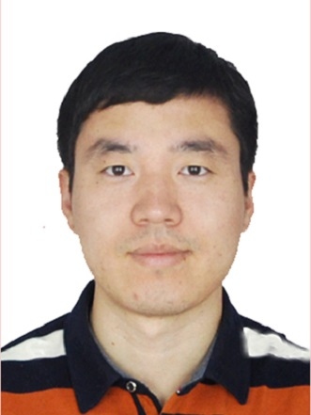
题目：Solving Discrete Logarithms over Small Characteristic Finite Fields
主讲人：庄金成
时间：2016年5月17日（星期二）10：00
地点：中国科学院信息工程研究所3号楼3224室

摘要：
The hardness of discrete logarithms underpins the security of many cryptographic protocols, including the widely adopted Diffie-Hellman key exchange protocol. In this talk, we will focus on solving discrete logarithms over small characteristic finite fields, especially the first heuristic quasi-polynomial time algorithm proposed by Barbulescu, Gaudry, Joux and Thome. We will firstly review how a sequence of breakthrough results culminated in the discovery of the BGJT algorithm. Then, we will explain why the efficiency of this algorithm comes at a cost. At last, we will present some improvements.

主讲人简介：
庄金成，2014年毕业于俄克拉荷马大学，获博士学位。现为中国科学院信息工程研究所助理研究员。研究方向为计算数论与密码学。研究成果发表在 Algorithmic Number Theory Symposium ( ANTS)，IEEE Transactions on Information Theory等会议和期刊。

