信息安全国家重点实验室2016年科技活动周系列学术讲座（五）
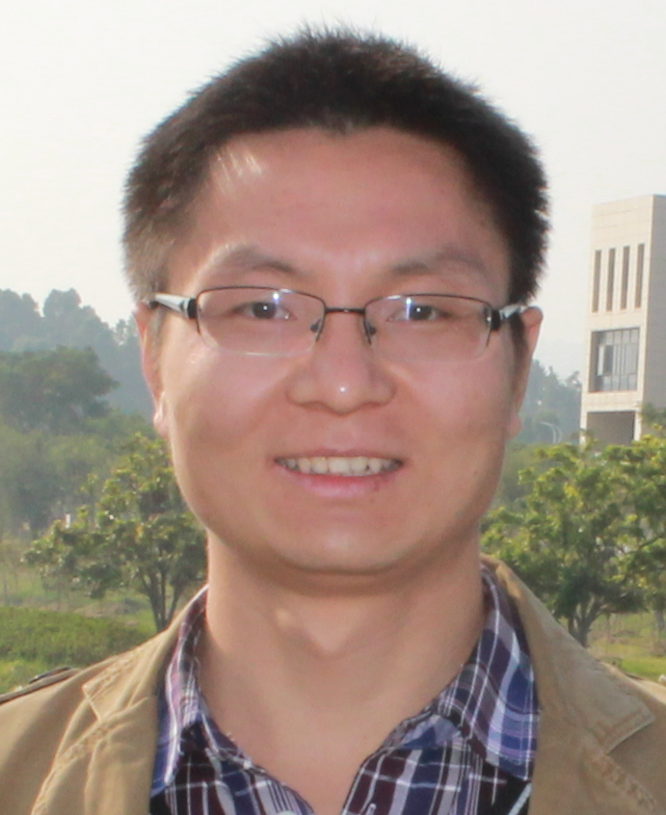
题目：Lattices and Group Signatures
主讲人：张江
时间：2016年5月18日（星期三）10:00
地点：中国科学院信息工程研究所3号楼3224室
摘要：
This talk mainly includes two parts. In the first part, we will talk about the definition of lattices, the hard problems on lattices, and some useful tools for lattice-based cryptography. In the second part, we show how to use those tools to construct an efficient group signature scheme. Our proposed scheme is more efficient than previous known lattice-based constructions by at least an O(log N) factor in both the group public key and the signature size, where N is the maximum number of group members. We achieve by using a new non-interactive zero-knowledge (NIZK) proof corresponding to a simple identity-encoding function. The security of our group signature can be reduced to the hardness of Small Integer Solution (SIS) and (Learning With Errors) LWE in the random oracle model.

主讲人简介：
张江，2015年毕业于中国科学院软件研究所，获计算机软件与理论专业博士学位, 现为密码科学技术国家重点实验室助理研究员, 主要研究方向为公钥密码和协议的可证明安全理论，以及基于格的密码学。近年多项成果发表在EUROCRYPT、AISACRYPT、PKC、TCS、CCPE等重要国际会议和国际期刊上。

